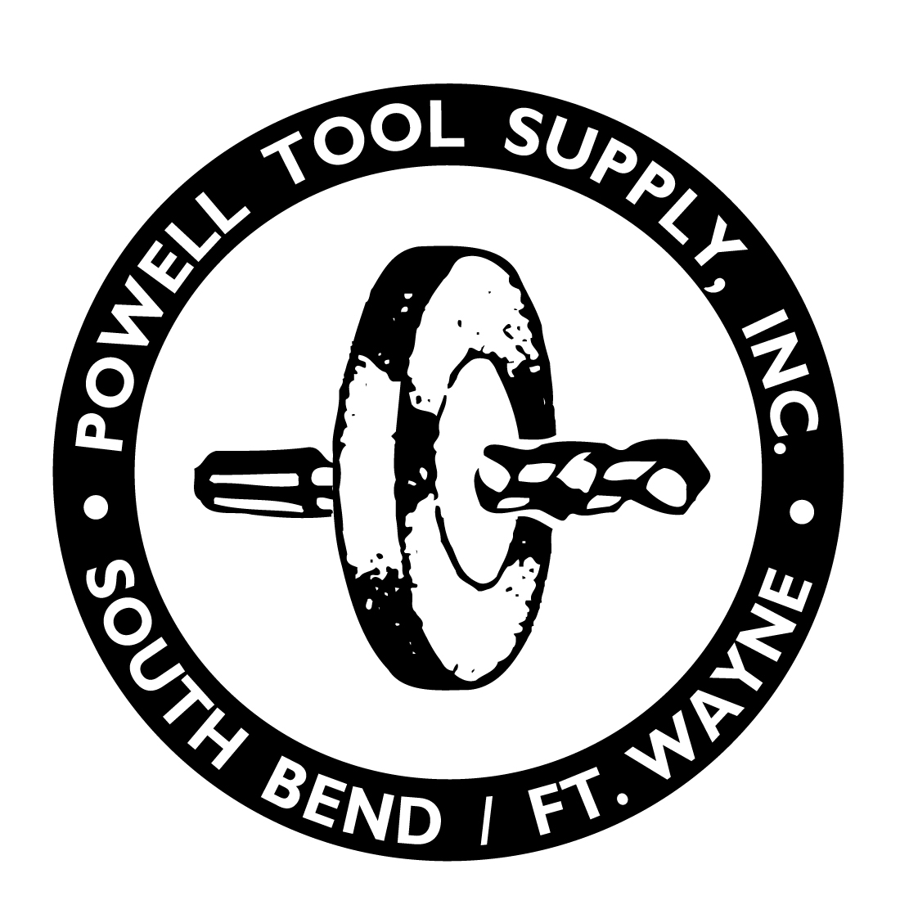
POWELL TOOL

CHALLENGE MACHINERY
CHEBOYGAN TAP & DIE
CHICAGO DIAL IND.
CHICAGO PNEUMATIC
CINCINNATI ELECTRICAL
CLAPP & HANEY TOOL
CLARK-CUTLER- McDERMOTT
COGSDILL
COILHOSE PNEUMATICS
COLLIS INC.
COMMAND TOOLING
CONCENTRIC TOOL
CONICAL TOOL
COSMO WHEELS
CRITERION MACHINE WORKS
CUSTANITE CORP.
CUSTOM CARBIDE
DACO
DAHLSTROM
DAKE CORP.
DAPRA CORP.
DAREX CORP.
DATA FLUTE
DAYTON ABRASIVE
DAYTON DRILL BUSHING
DAYTON PROGRESS
DEE BLAST CORP.
DESERT CARBIDE
DESMOND-STEPHAN
DE-STA-CO
DETROIT HOIST & MACH.
DEVCON
DICAR DIAMOND TOOL
DIJET
DIP SEAL PLASTICS
DORIAN TOOL
DRILL MASTERS OF VT.
DUMONT CORP.
DURANT TOOL CO.
DYER CO.
DYKEM
DYNABRADE
DYNOMAX
EAGLE GRINDING WHEEL
EDMAR ABRASIVE
EDWARD ANDREWS INT.
EG/WESTLINGS, INC.
EKLIND
SUPPLY

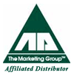
Affiliated Distributors
ALPHABETICAL BY MANUFACTURER

HENDERSONVILLE GAGE
HODELL-NATCO IND.
HOLDRIDGE CO.
HOUGEN
HORN
HUFFMAN S. E.
HUOT
HURON MACHINE PRODUCTS
HYBCO PRODUCTS
INDUSTRIAL TECTONICS
INTERNATIONAL DIAMOND
ISOSTATIC IMDUSTRIES
J & M DIAMOND TOOL CO.
J & S TOOL CO.
JACOBS MFG
JANCY ENGINEERING
JARVIS PRODUCTS CORP.
JERGENS
JET PULSER
JET GROUP, THE
K.E.I.
KAISER TOOL
KALAMAZOO CHUCK
KALAMAZOO IND.
KALAMAZOO MACHINE TOOL
KELLER MFG.
KK/MACHINE TOOLS
K.O. LEE
KONCOR IND.
K-TOOL
K.T.S. INDUSTRIES, INC.
KYOCERA IND. CERAMICS
L.S.P. INDUSTRIES
LAMINA
LAVALLEE AND IDE
LIFT-ALL
LINK INDUSTRIES
LISTA INTERNATIONAL
LITTLE GIANT PUMP
LMT USA
LUTZ FILE AND TOOL
LYNDEX CORP.
LYONS METAL PRODUCTS
M&M PRECISION SYSTEMS
M.A. FORD MFG.
M.T.I. ( MITUTOYO)
EKSTROM CARLSON
ELECTRO-MECHANO CO.
ELLIOT CO.
EMUGE CORP.
EPB, INC
ERNST WINTER & SON
ETTCO TOOL & MACH
EVEREDE TOOL CO.
EVERETT INDUSTRIES
EXAIR CORP.
F & D TOOL
FEDERAL CARBIDE
FEDERAL PRODUCTS
FIELD ABRASIVES
FISKE BROS. REFINING
FITZ RITE PRODUCTS
FLEXBAR MACHINE CO.
FLORIDA PNEUMATIC
FLYNN MFG. CO.
FORD, M. A. MFG.
FORM ROLL DIE CORP.
FOWLER, FRED V.
FULLERE, W. L.
FASTCUT
GAGE CO.
GAMMONS HOAGLUND
GAR ELECTROFORMING
GAYLEE SAW/BITNER TOOL
GELBER PUMPS
GENERAL OIL CO.
GENESEE MFG.
GIDDINGS & LEWIS TOOL
GLASTONBURY GAGE
GLENBARD REAMERS
GRANT MFG. & MACH
GRAYMILLS
GRINDING & POLISHING
GROBET FILE
H. E. LONG
H. G. SCCHNEIDER
HAMMOND MACHINERY
HANSON, C. H. CO.
HARIG MFG. CORP.
HASSAY SAVAGE BROACH
HAYDEN TWIST DRILL
HEINEMANN SAW
HEINRICH TOOLS
HEMCO
ABER CUTTERS
ABSORBENT
ACE DRILL CORP.
ADVENT
AERO-MOTIVE MFG.
AIR TURBINE TECH.
AIR-HYDRAULICS
AJAX TOOL WORKS
AKRO-MILS CO.
ALBRECHT
ALFORD POLK
ALL AMERICAN PRODUCTS
ALORIS TOOL CO.
ALLIED MACHINE
AMERICAN DIAMOND SAW
AMPLEX
ANDERSON PRODUCTS
APCO MOSSBERG
APEX
ARC ABRASIVES
ASSOCIATED RAYMOND
AWARD CUTTER
B.C.COMP.EZ LOK
BALZERS TOOL COATINGS
BARRY CONTROLS
BELCAR
BELKNAP, VAN E.
BELMONT TOOL & ENG.
BELT GRINDING ACCESS.
BESLY PRODUCTS
BIG BEAR ENT.
BLADE MFG.
BOKUM TOOL
BOREL AND DUNNER
BORITE MFG.
BRADY CORPORATION
BRANCH MFG. CO.
BRIGHTON-BEST MFG.
BRUNNER AND LAY
BUCK CHUCK CO.
BUILD-ALL CORP.
BURR KING MFG.
C.R.C. CHEMICAL USA
CAMERON, GORDON N.
CARBIDE ENERGY
CARBIDE PROBES
CARBITBORE CORP.
CARBOLOY, INC.
CARR TOOL CO.
CENTAUR
CERATIP

POWELL TOOL SUPPLY
SCULLY JONES
SECO
SELLSTROM
SETCO INDUSTRIES
SEV-CAL TOOL
SIMONDS INDUSTRIES
SIZE CONTROL
SKIDMORE-WELHELM MFG.
SLATER TOOLS
SLOCOMB, J.T. CO.
SONNET TOOL
SOPKO, WM. AND SON
SORBENT PRODUCTS CO.
SOUTHERN GAGE
SPECIALTY TOOLS INC.
SPHERIC
SPIE TOOL
SPINDLEMATE
SPIRAKUT PRODUCTS
SPIRALCOOL CO.
STANDARD ABRASIVE
STANLEY-PROTO
STEVENS ENGINEERING
STICKS & STONES UNLIMITED
STOCKHAUSEN
STRYCO CO.
STUART, D.A. OIL
STUHR MFG.
SUBURBAN INDUSTRIES
SUPERION
SUPERIOR ABRASIVES
SUPERIOR MFG. (NOTRAX)
SUPER TOOL
SUTTON TOOL
TAPMAGIC
TAPMATIC CORP.
TELCO MACHINE TOOL
TENNESSEE ABRASIVES
THK AMERICA
THREAD FORM
TI-COATING
TITAN TOOL CO.
TITAN TOOL SUPPLY
TITEX TOOLS
TOOL STEEL SERVICE
TROYKE
TM SMITH
ULTRA TOOL
UNBRAKO
UNI-MIST
UNI-TEK MFG.
UNITED ABRASIVES
UNIVERSAL SUPER ABRASIVES
UNIVERSAL VISE
V-B MANUFACTURING
VERMONT GAGE
VERNON DEVICES
VLIER
W.A.WHITNEY
W.F. WELLS
W.M. ZIEGLER TOOL
WAHLSTROM FLOAT-LOCK
WALKER, O.S.
WALTER / TITEX / PROTOTYP
WALTON COMPANY
WAUKESHA CUTTING TOOLS
WEBER INDUSTRIAL
WEDGEMILL TOOL
WELDON TOOL
WELLS MFG.
WHALLEY COMPANY
WHITNEY TOOL CO.
WIDELL INDUSTRIES
WOHLHAUPTER
WOLVERINE CNC MFG
WOODSON TOOL
WRIGHTS MACHINE
YOUNG BROS. STAMP WORKS
MAGNA
MAHR/FEDERAL
MALCO SAW CO.
MARENA INDUSTRIES
MARKAL
MARSHALL
MASTER CHEMICAL
MAXWELL
MAYHEW
McCROSKY TOOL
MERCURY MARKING DEVICES
METAL CUTTING TOOLS
METRIC COMPONENTS
MEYER GAGE CO.
MICHIGAN DRILL CORP.
MICHIGAN PNEUMATIC
MICRO CARBIDE TOOL
MILWAUKEE ELEC. TOOL
MILWAUKEE SPINDLE & SLIDE
MILWAUKEE SPRAYER
MILWAUKEE TOOL & EQ.
MITE BITE
MODERN ABRASIVE CO.
MORGOOD TOOLS
MUSKEGON TOOL INDS.
NATIONAL DETROIT
NELCO
NIAGARA CUTTER
NICO
NORTH AMERICAN TOOL
NORTHWESTERN
NORTON ABRASIVES
NU-MATIC GRINDERS
ORBITFORM
OSBORN INT'L
OSG
OTTAVINO
OYLBELT
P.M.C. GAGE CO.
PALMGREN STEEL PROD.
P.M.C. GAGE CO.
PALMGREN STEEL PROD.
PARMA MFG.
PEERLESS SAW CO.
PFERD
PIONEER PUMPS
POWERMATIC
PRATT BURNERD AMERICA
PRECISION BRAND PROD
PRECISION COMPONENTS
PRECISION INTL.
PRECISION DORMER
PRECISION-MARSHALL STEEL
PRODUCTION MACHINERY
PROTECTIVE INDUSTRIAL PRODUCTS
QUALITY CHASER CO.
QUALTECH
R&F MICRO TOOL CO.
RADIAC ABRASIVS
RAMPART
RAMS ROCKFORD PROD.
RAMSEY TOOL & MACHINE
RAYOVAC
READY TOOL CO.
REGAL-BELOIT CORP.
RENISHAW
RETENTION KNOB SUPPLY
REGIBORE LIMITED
RITEN INDUSTRIES
ROBB JACK CORP.
ROCK RIVER TOOL
ROGERS RATCHET
ROHM PROD. OF AMERICA
ROTARY TECHNOLOGIES
ROYAL PRODUCTS
RSVP TOOLING
RUTHMAN MACHINERY
S-T INDUSTRIES, INC.
S.P.I., INC.
SAFE-TECH CORP.
SCHAFFER MACHINE
SCIENTIFIC COATING
(800) 647-0787 Local (574) 289-4811 Fax (574) 289-3504

TWO LOCATIONS TO SERVE YOU:

1338 Mishawaka Ave. South Bend, IN 46615
Phone: 574.289.4811 Fax: 574.289.3504 Toll Free: 800.647.0787

7616 DiSalle Blvd, Suite D Fort Wayne, IN 46825
Phone: 260.590.8877 Fax: 260.490.8866 Toll Free: 800-621-9995

Visit us @ www.PowellTool.com

